**a)Create tables and Insert data :**

Create Table CUSTOMERS(

Customer_ID integer Primary Key,

Customer_Name varchar(50) not null,

Customer_Address varchar(50) not null,

Customer_Email varchar(50),

Contact_Number varchar(50)

);

INSERT INTO CUSTOMERS VALUES (101, 'Rahim', 'Gulshan', 'rahim@gmail.com', '8801723456781');

INSERT INTO CUSTOMERS VALUES (102, 'Karim', 'Banani', 'karim@gmail.com', '8801723456782');

INSERT INTO CUSTOMERS VALUES (103, 'Salma', 'Dhanmondi', 'salma@gmail.com', '880172345678');

INSERT INTO CUSTOMERS VALUES (104, 'Tania', 'Mohakhali', 'tania@gmail.com', '8801723456784');

INSERT INTO CUSTOMERS VALUES (105, 'Rifat', 'Bashundhara', 'rifat@gmail.com', '8801723456785');

INSERT INTO CUSTOMERS VALUES (106, 'Arif', 'Farmgate', 'arif@gmail.com', '8801723456786');

INSERT INTO CUSTOMERS VALUES (107, 'Nila', 'Shahbagh', 'nila@gmail.com', '8801723456787');

INSERT INTO CUSTOMERS VALUES (108, 'Sadia', 'Uttara', 'sadia@gmail.com', '8801723456788');

INSERT INTO CUSTOMERS VALUES (109, 'Fahim', 'Motijheel', 'fahim@gmail.com', '8801723456789');

INSERT INTO CUSTOMERS VALUES (110, 'Jarin', 'Malibagh', 'jarin@gmail.com', '8801723456790');

Create Table SUPPLIERS(

Supplier_ID integer Primary Key,

Supplier_Name varchar(50),

Address varchar(50),

Contact_Number varchar(50)

);

INSERT INTO SUPPLIERS VALUES (201, 'Rahim', 'Gulshan', '8801711111111');

INSERT INTO SUPPLIERS VALUES (202, 'Karim', 'Banani', '8801711111112');

INSERT INTO SUPPLIERS VALUES (203, 'Alif', 'Dhanmondi', '8801711111113');

INSERT INTO SUPPLIERS VALUES (204, 'Amin', 'Shahbagh', '8801711111114');

INSERT INTO SUPPLIERS VALUES (205, 'Habib', 'Mohakhali', '8801711111115');

INSERT INTO SUPPLIERS VALUES (206, 'Zaman', 'Farmgate', '8801711111116');

INSERT INTO SUPPLIERS VALUES (207, 'Nasir', 'Motijheel', '8801711111117');

INSERT INTO SUPPLIERS VALUES (208, 'Fahim', 'Bashundhara', '8801711111118');

INSERT INTO SUPPLIERS VALUES (209, 'Hasan', 'Uttara', '8801711111119');

INSERT INTO SUPPLIERS VALUES (210,'Rifat', 'Malibagh', '8801711111120');

Create Table EMPLOYEES(

Employee_ID integer Primary Key,

Employee_Name varchar(50),

Role varchar(50),

Salary integer,

Employee_Email varchar(50),

PhoneNumber varchar(50)

);

INSERT INTO EMPLOYEES VALUES (301, 'Dev', 'Manager', 50000, 'dev@gmail.com', '01711-111111');

INSERT INTO EMPLOYEES VALUES (302, 'Priya', 'Accountant', 45000, 'priya@gmail.com', '01712-222222');

INSERT INTO EMPLOYEES VALUES (303, 'Rana', 'Accountant', 60000, 'rana@gmail.com', '01713-333333');

INSERT INTO EMPLOYEES VALUES (304, 'Nila', 'HR', 40000, 'nila@gmail.com', '01714-444444');

INSERT INTO EMPLOYEES VALUES (305, 'Amit', 'Supervisor', 35000, 'amit@gmail.com', '01715-555555');

INSERT INTO EMPLOYEES VALUES (306, 'Sima', 'salesman', 30000, 'sima@gmail.com', '01716-666666');

INSERT INTO EMPLOYEES VALUES (307, 'Rafi', 'salesman', 42000, 'rafi@gmail.com', '01717-777777');

INSERT INTO EMPLOYEES VALUES (308, 'Liza', 'salesman', 48000, 'liza@gmail.com', '01718-888888');

INSERT INTO EMPLOYEES VALUES (309, 'Tina', 'salesman', 40000, 'tina@gmail.com', '01719-999999');

INSERT INTO EMPLOYEES VALUES (310, 'Arif', 'Driver', 32000, 'arif@gmail.com', '01710-000000');

Create Table PUBLISHERS(

Publisher_ID integer Primary Key,

Publisher_Name varchar(50) not null,

Publisher_Address varchar(50) ,

Publisher_Email varchar(50),

Contact_Number varchar(50)

);

INSERT INTO PUBLISHERS VALUES (401, 'Srishti Publications', 'Kolkata,India', 'contact@srishtipub.com', '+91-33-12345678');

INSERT INTO PUBLISHERS VALUES(402, 'Bengali Classics Press', 'Dhaka,Bangladesh', 'info@bengaliclassicspub.com', '+880-2-98765432');

INSERT INTO PUBLISHERS VALUES(403, 'Bengal Literature House', 'Chittagong,Bangladesh', 'sales@bengalliteraturehouse.com', '+880-31-23456789');

INSERT INTO PUBLISHERS VALUES(404, 'Ray & Co. Publishers', 'Kolkata,India', 'info@raycopub.com', '+91-33-87654321');

INSERT INTO PUBLISHERS VALUES(405, 'Kodansha International', 'Tokyo,Japan', 'info@kodansha-intl.com', '+81-3-12345678');

INSERT INTO PUBLISHERS VALUES(406, 'Shinchosha Publishing', 'Tokyo,Japan', 'contact@shinchosha.com', '+81-3-98765432');

INSERT INTO PUBLISHERS VALUES(407, 'Tokyo Book Publishers', 'Tokyo,Japan', 'info@tokyobookpub.com', '+81-3-23456789');

INSERT INTO PUBLISHERS VALUES(408, 'Vintage Books Japan', 'Tokyo,Japan', 'sales@vintagebooksjp.com', '+81-3-34567890');

INSERT INTO PUBLISHERS VALUES(409, 'Bungeishunju Ltd', 'Tokyo,Japan', 'support@bungeishunju.com', '+81-3-45678901');

INSERT INTO PUBLISHERS VALUES(410, 'Shodensha Publishing', 'Tokyo,Japan', 'info@shodenshapub.com', '+81-3-56789012');

INSERT INTO PUBLISHERS VALUES(411,'kakoli prokashoni', 'Dhaka,Bangladesh', 'info@kakoliProkashonipub.com', '+880-2-98766932');

INSERT INTO PUBLISHERS VALUES(412, 'Ranjan Prakashalay', 'Kolkata,India', 'info@raypakpub.com', '+91-33-87894321');

INSERT INTO PUBLISHERS VALUES (413, 'Sahitya Sarowar', 'Agra,India', 'contact@sahityapub.com', '+91-33-12355678');

INSERT INTO PUBLISHERS VALUES (414, 'PENGUIN RANDOM HOUSE INDIA', 'Agra,India', 'contact@penguinpub.com', '+91-33-12354578');

INSERT INTO PUBLISHERS VALUES (415, 'knopf Doubleday', 'New York,US', 'contact@knopfpub.com', '+11-33-12355678');

INSERT INTO PUBLISHERS VALUES (416, 'shanghai Publications', 'shanghai,china', 'contact@shanghaipub.com', '+51-33-12355678');

Create Table AUTHORS(

Author_ID integer Primary Key,

Author_Name varchar(50),

Nationality varchar(50) not null,

Author_Email varchar(50)

);

INSERT INTO AUTHORS VALUES (501, 'Kazi Nazrul Islam', 'Bangladeshi', 'kazinazrul@gmail.com');

INSERT INTO AUTHORS VALUES (502, 'Jasim Uddin', 'Bangladeshi', 'jasimuddin@gmail.com');

INSERT INTO AUTHORS VALUES (503, 'Humayun Ahmad', 'Bangladeshi', 'humayun@gmail.com');

INSERT INTO AUTHORS VALUES (504, 'Muhammed Zafar Iqbal', 'Bangladeshi', 'mzafar@gmail.com');

INSERT INTO AUTHORS VALUES (505, 'Rabindranath Tagore', 'Indian', 'rabindranath@gmail.com');

INSERT INTO AUTHORS VALUES (506, 'Satayjit Roy', 'Indian','Satayjit@gmail.com');

INSERT INTO AUTHORS VALUES (507, 'Bibhutibhusan Bandypadhyay', 'Indian', 'Bibhutibhusan@gmail.com');

INSERT INTO AUTHORS VALUES (508, 'Haruki Murakami', 'Japanese', 'Haruki@gmail.com');

INSERT INTO AUTHORS VALUES (509, 'Yukio Mishima', 'Japanese', 'Yukio@gmail.com');

INSERT INTO AUTHORS VALUES (510, 'Osamu Dazai','Japanese', 'Osamu@gmail.com');

Create Table GENRE(

Genre_ID integer Primary Key,

Genre_Title varchar (100),

Genre_Details varchar(1000)

);

INSERT INTO GENRE VALUES(601, 'Poetry', 'Poetry collections that explore emotions, spirituality, and social issues');

INSERT INTO GENRE VALUES(602, 'Classic Literature', 'Classic novels focusing on cultural identity, love, and historical themes');

INSERT INTO GENRE VALUES(603, 'Folk Literature', 'Folk-based literature that highlights rural life, tradition, and culture');

INSERT INTO GENRE VALUES(604, 'Drama', 'Works focusing on dramatic storytelling, often with strong social and cultural themes');

INSERT INTO GENRE VALUES(605, 'Contemporary Fiction', 'Modern fiction that blends surrealism, identity, and existential themes');

INSERT INTO GENRE VALUES(606, 'Psychological Fiction', 'Explores deep psychological and emotional turmoil within characters');

INSERT INTO GENRE VALUES(607, 'Modern Fiction', 'Fiction that explores modern societal issues, personal struggles, and existentialism');

INSERT INTO GENRE VALUES(608, 'Short Stories', 'Short fictional works that often explore human nature and relationships');

INSERT INTO GENRE VALUES(609, 'Literary Fiction', 'Highly literary works focusing on complex characters, language, and existential themes');

INSERT INTO GENRE VALUES(610, 'Modern Japanese Literature', 'Exploring the tensions between traditional and modern Japan in literary form');

INSERT INTO GENRE VALUES(611, 'historical fiction','recreates past events, blending historical facts with imaginative storytelling to provide a compelling narrative set in a specific historical period');

Create Table BOOKS(

Book_ID integer Primary Key,

Book_Name varchar(50),

Author_ID integer,

Publisher_ID integer,

Genre_ID integer,

Price integer,

Language varchar(50),

StockQuantity integer,

foreign key (Author_ID) references AUTHORS (Author_ID),

foreign key (Publisher_ID) references PUBLISHERS(Publisher_ID),

foreign key (Genre_ID) references GENRE(Genre_ID)

);

INSERT INTO BOOKS VALUES(1, 'Gitanjali',505,401,601, 300, 'Bengali', 50);

INSERT INTO BOOKS VALUES(2,'Amar Bondhu Rashed',504,411 ,611,200,'bengali',50);

INSERT INTO BOOKS VALUES(3, 'The Home and the World',505,401,602, 250, 'Bengali', 30);

INSERT INTO BOOKS VALUES(4, 'Bidrohi',501,402,601, 210, 'Bengali', 40);

INSERT INTO BOOKS VALUES(5, 'Ruposhi Bangla',502,402,601, 180, 'Bengali', 55);

INSERT INTO BOOKS VALUES(6, 'Shonar Pahar',502,403,603, 240, 'Bengali', 45);

INSERT INTO BOOKS VALUES(7, 'Pather Panchali',507,412,604, 350, 'Bengali', 35);

INSERT INTO BOOKS VALUES(8, 'Apu Trilogy',506,404,604, 300, 'Bengali', 50);

INSERT INTO BOOKS VALUES(9, 'Norwegian Wood',508,405,609, 500, 'Japanese', 20);

INSERT INTO BOOKS VALUES(10, 'Kafka on the Shore',508,405,605, 450, 'Japanese', 25);

INSERT INTO BOOKS VALUES(11, 'The Wind-Up Bird Chronicle', 508,406,607, 550, 'Japanese', 30);

INSERT INTO BOOKS VALUES(12, '1Q84',508,406,607, 600, 'Japanese', 40);

INSERT INTO BOOKS VALUES(13, 'The Temple of the Golden Pavilion',509,407,606, 300, 'Japanese', 45);

INSERT INTO BOOKS VALUES(14, 'Confessions of a Mask',509,407,606, 250, 'Japanese', 50);

INSERT INTO BOOKS VALUES(15, 'No Longer Human',509,408,606, 280, 'Japanese', 60);

INSERT INTO BOOKS VALUES(16, 'Spring Snow',509, 408, 607, 320, 'Japanese', 55);

INSERT INTO BOOKS VALUES(17, 'No Longer Human',510,409, 606, 400, 'Japanese', 30);

INSERT INTO BOOKS VALUES(18, 'The Setting Sun',510,409,607, 380, 'Japanese', 35);

INSERT INTO BOOKS VALUES(19, 'Independence',510,409,607, 350, 'Japanese', 25);

INSERT INTO BOOKS VALUES(20, 'Run, Melos!',510,410,608, 200, 'Japanese', 40);

INSERT INTO BOOKS VALUES(21, 'Gitanjali',505,413,601, 400, 'english', 70);

INSERT INTO BOOKS VALUES(22, 'Norwegian Wood',508,414,609, 500, 'english', 30);

INSERT INTO BOOKS VALUES(23, 'Kafka on the Shore',508,415,605, 500, 'english', 50);

INSERT INTO BOOKS VALUES(24, 'The Wind-Up Bird Chronicle', 508,416,607,600, 'Chinese', 60);

INSERT INTO BOOKS VALUES(25, '1Q84',508,416,607, 600, 'Chinese', 80);

Create Table ORDERS(

Order_ID integer PRIMARY KEY,

Customer_ID integer,

Order_Date date,

Total_Amount integer,

Total_Quantity integer,

Employee_ID integer,

foreign key (Customer_ID) references CUSTOMERS(Customer_ID),

foreign key(Employee_ID) references EMPLOYEES(Employee_ID)

);

INSERT INTO ORDERS VALUES (701, 101, '2024-12-01', 700, 3,306);

INSERT INTO ORDERS VALUES (702, 102, '2024-12-01', 920, 4,307);

INSERT INTO ORDERS VALUES (703, 103, '2024-12-01', 420, 2,307);

INSERT INTO ORDERS VALUES (704, 101, '2024-12-02', 1800,4,309);

INSERT INTO ORDERS VALUES (705, 102, '2024-12-02', 320, 1,308);

INSERT INTO ORDERS VALUES (706, 105, '2024-12-02', 450, 1,309);

INSERT INTO ORDERS VALUES (707, 104, '2024-12-02', 400, 1,307);

INSERT INTO ORDERS VALUES (708, 106, '2024-12-02', 800, 2,308);

INSERT INTO ORDERS VALUES (709, 107, '2024-12-02', 1000, 2,306);

Create Table ORDER_DETAILS(

Orderdetails_ID integer PRIMARY KEY,

Order_ID integer,

Book_ID integer,

Quantity integer,

Sub_Total_price integer,

foreign key (Order_ID) references ORDERS(Order_ID),

foreign key (Book_ID) references BOOKS(Book_ID)

);

INSERT INTO ORDER_DETAILS VALUES (801, 701, 1, 1, 300);

INSERT INTO ORDER_DETAILS VALUES (802, 701, 2, 2, 400);

INSERT INTO ORDER_DETAILS VALUES (803, 702, 3, 2, 500);

INSERT INTO ORDER_DETAILS VALUES (804, 702, 4, 2, 420);

INSERT INTO ORDER_DETAILS VALUES (805, 703, 5, 1, 180);

INSERT INTO ORDER_DETAILS VALUES (806, 703, 6, 1, 240);

INSERT INTO ORDER_DETAILS VALUES (807, 704, 11, 2, 1100);

INSERT INTO ORDER_DETAILS VALUES (808, 704, 7, 2, 700);

INSERT INTO ORDER_DETAILS VALUES (809, 705, 16, 1, 320);

INSERT INTO ORDER_DETAILS VALUES (810, 706, 10, 1, 450);

INSERT INTO ORDER_DETAILS VALUES (811, 707, 20, 2, 400);

INSERT INTO ORDER_DETAILS VALUES (812, 708, 21, 2, 800);

INSERT INTO ORDER_DETAILS VALUES (813, 709, 22, 1, 500);

INSERT INTO ORDER_DETAILS VALUES (814, 709, 23, 1, 500);

Create Table SUPPLY_DETAILES(

Supply_ID integer Primary key,

Book_ID integer,

Book_Name varchar(50),

Author_ID integer,

Author_Name varchar(50),

Language varchar(50),

Genre_ID integer,

Quantity integer,

Sub_Total_Price float,

Publisher_ID integer,

Supplier_ID integer,

foreign key (Book_ID) references BOOKS (BOOK_ID),

foreign key (Author_ID) references AUTHORS (Author_ID),

foreign key (Publisher_ID) references PUBLISHERS(Publisher_ID),

foreign key (Supplier_ID) references SUPPLIERS (Supplier_ID),

foreign key (Genre_ID) references GENRE (Genre_ID)

);

INSERT INTO SUPPLY_DETAILES VALUES (901, 1, 'Gitanjali', 505, 'Rabindranath Tagore', 'Bengali', 601, 20, 600, 401, 201);

INSERT INTO SUPPLY_DETAILES VALUES (902, 2, 'Amar Bondhu Rashed', 504, 'Muhammed Zafar Iqbal', 'Bengali', 611, 15, 300, 411, 201);

INSERT INTO SUPPLY_DETAILES VALUES (903, 3, 'The Home and the World', 505, 'Rabindranath Tagore', 'Bengali', 602, 10, 250, 401, 202);

INSERT INTO SUPPLY_DETAILES VALUES (904, 4, 'Bidrohi', 501, 'Kazi Nazrul Islam', 'Bengali', 601, 30, 630, 402, 202);

INSERT INTO SUPPLY_DETAILES VALUES (905, 5, 'Ruposhi Bangla', 502, 'Jasim Uddin', 'Bengali', 601, 25, 450, 402, 203);

Create Table INVENTORY(

Book_ID integer Primary Key,

Total_Stock integer,

Sold_Stock integer,

foreign key (Book_ID) references BOOKS (BOOK_ID)

);

INSERT INTO INVENTORY VALUES (1, 50, 30);

INSERT INTO INVENTORY VALUES (2, 40, 25);

INSERT INTO INVENTORY VALUES (3, 30, 20);

INSERT INTO INVENTORY VALUES (4, 40, 10);

INSERT INTO INVENTORY VALUES (5, 55, 30);

INSERT INTO INVENTORY VALUES (6, 45, 20);

INSERT INTO INVENTORY VALUES (7, 35, 15);

INSERT INTO INVENTORY VALUES (8, 50, 10);

INSERT INTO INVENTORY VALUES (9, 20, 5);

INSERT INTO INVENTORY VALUES (10, 25, 15);

**b) query and output(SS):**

**1)query to see datas store in table**

**(A) CUSTOMERS TABLE**

select* from CUSTOMERS;

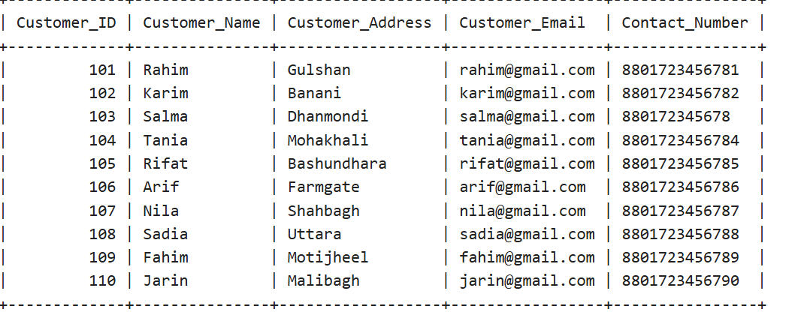

**(B) SUPPLIERS TABLE**

select* from SUPPLIERS;

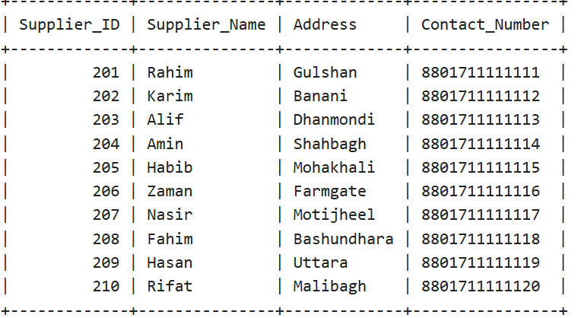

**(C) EMPLOYEES TABLE**

select* from EMPLOYEES;

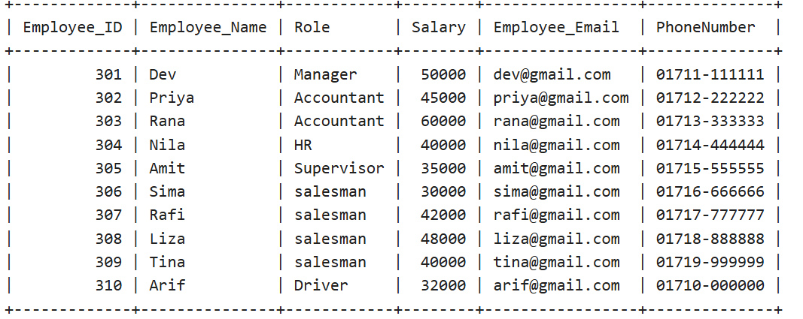

**(D) AUTHORS TABLE**

select* from AUTHORS;

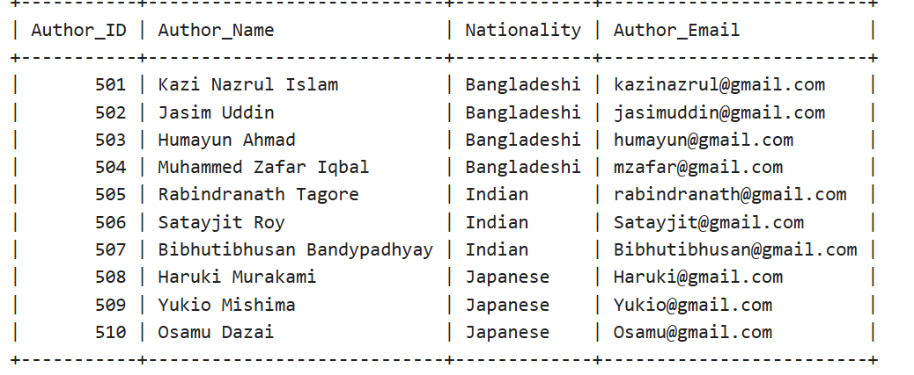

**(E) PUBLISHERS TABLE**

select* from PUBLISHERS;

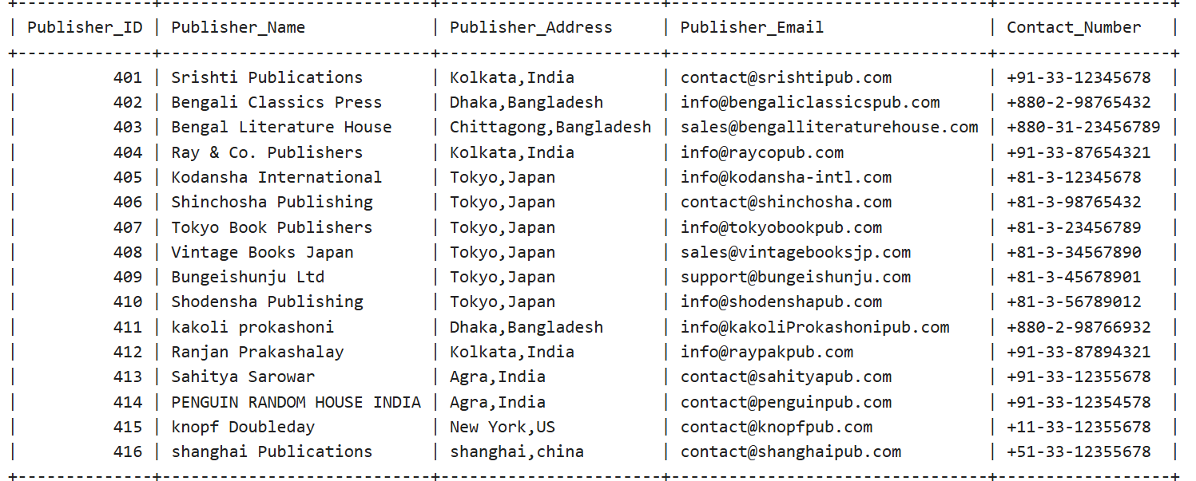

**(F) GENRE TABLE**

select* from GENRE;

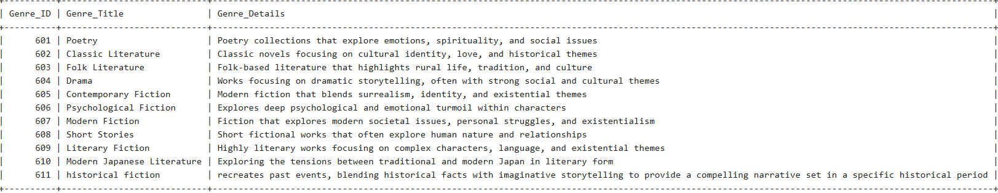

**(G) BOOKS TABLE**

select* from BOOKS;

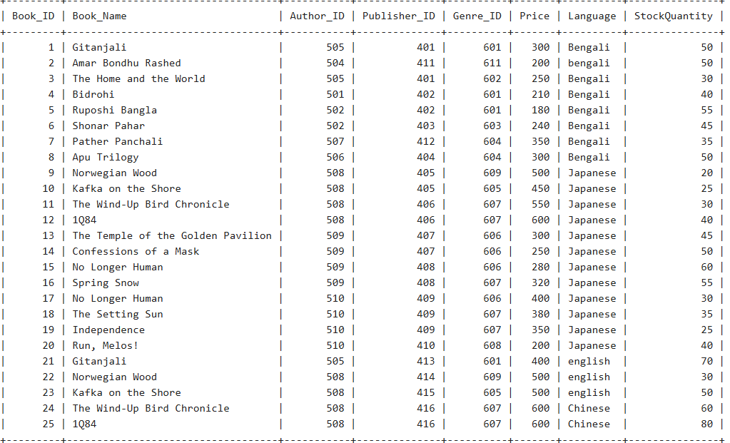

**(H) ORDERS TABLE**

select * from ORDERS; 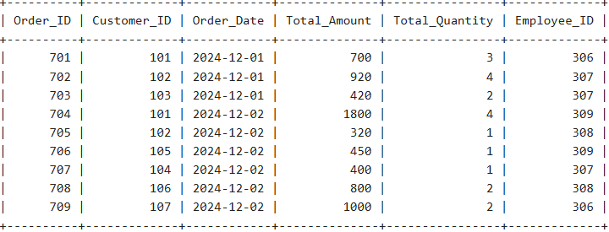

**(I) order_details TABLE**

select * from order_details;

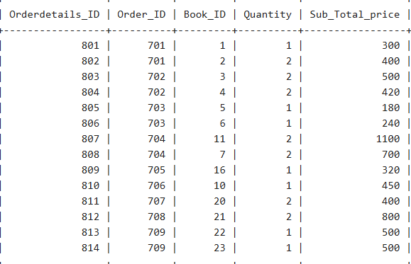

**(J) SUPPLY_DETAILES TABLE**

select *from SUPPLY_DETAILES;

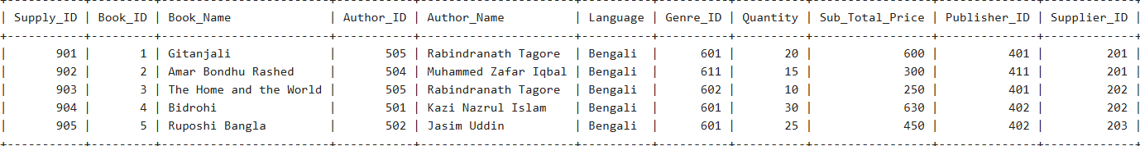

**(K) INVENTORY TABLE**

select * from INVENTORY;

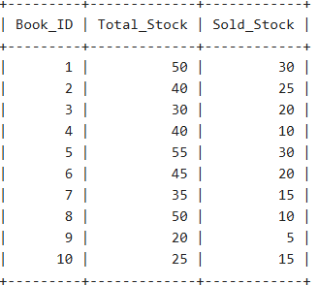

**2.Query to delete an employee's data from employee table :**

delete from EMPLOYEES where Employee_ID=305;

select *from EMPLOYEES;

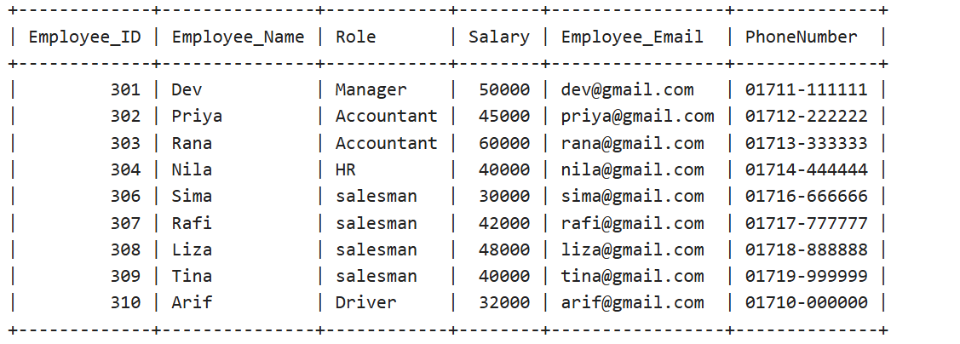

**3.Query to update info of an employee from employee table:**

update EMPLOYEES set Role ='Superviser' where Employee_ID=306;

select *from EMPLOYEES;

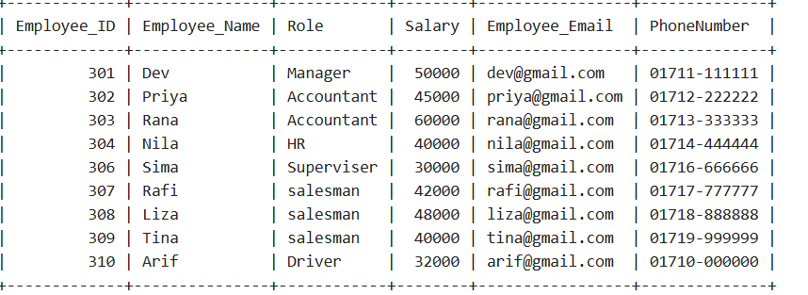

**4.Query to add department name(dept_name) column in Employee table:**

alter table EMPLOYEES add dept_name varchar(50);

update EMPLOYEES set dept_name = case

when Role ='Manager' then 'sales'

when Role ='Accountant' then 'accounting'

when Role ='HR' then 'HR'

when Role ='salesman' then 'sales'

when Role ='Superviser' then 'sales'

when Role ='Driver' then 'sales'

ELSE dept_name

END;

select * from EMPLOYEES;

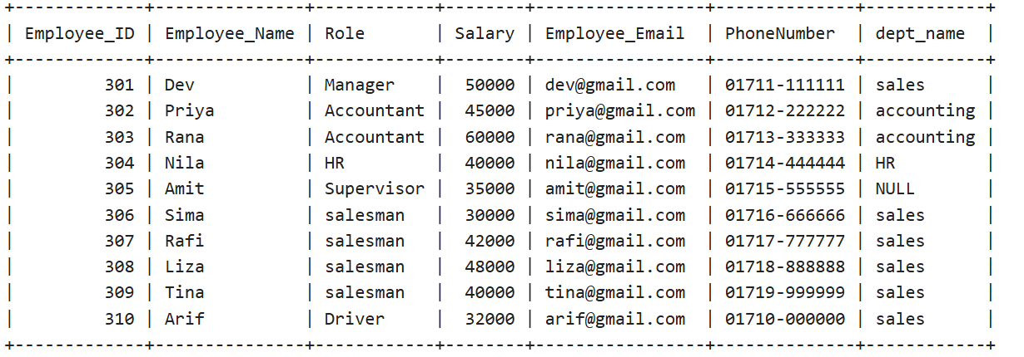

**5.Query to see a specific language's books:**

Select BOOK_ID, Book_Name, Author_Name, Publisher_Name, Genre_Title, Price, language, StockQuantity

from

BOOKS natural join AUTHORS natural join PUBLISHERS natural join GENRE

where language ='Japanese';

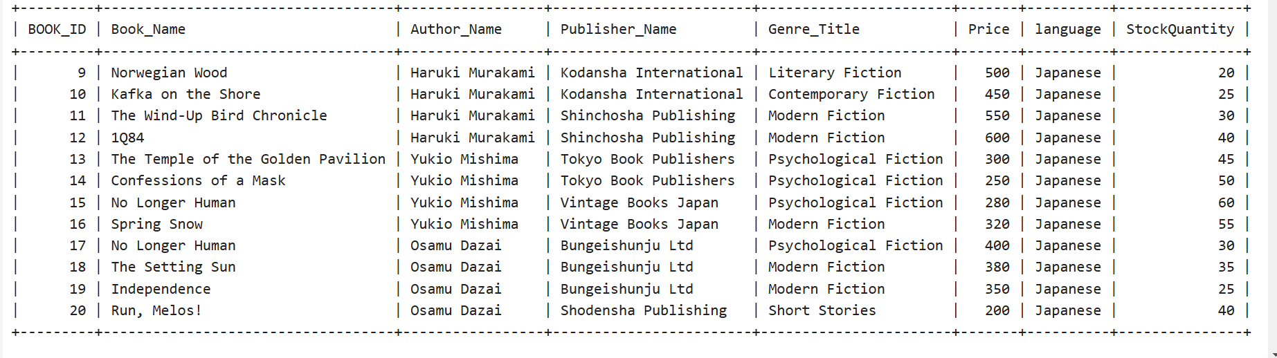

**6.Query to check whether this bookstore has an English version of the book "Gitanjali" :**

Select BOOK_ID, Book_Name, Author_Name, Publisher_Name, Genre_Title, Price, language, StockQuantity

from

BOOKS natural join AUTHORS natural join PUBLISHERS natural join GENRE

where language ='english' AND Book_Name='Gitanjal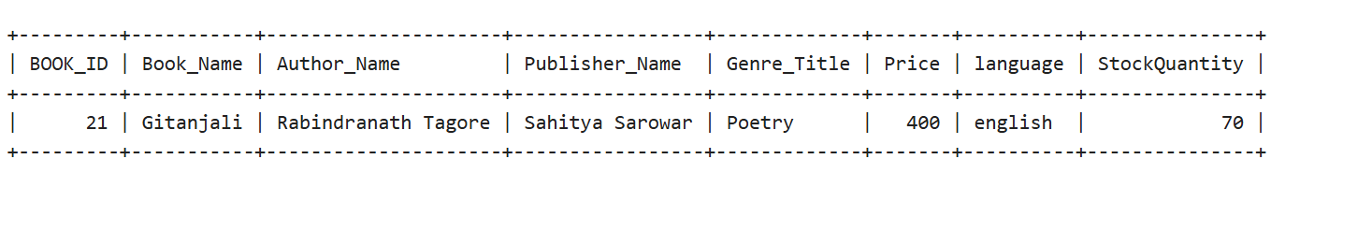

**7.Query to see a specific author's books :**

Select

Book_Name, Author_Name, language, Publisher_Name, Genre_Title, Price, StockQuantity

From

BOOKS natural join AUTHORS natural join PUBLISHERS natural join GENRE

where Author_Name='Rabindranath Tagore'

order by Book_Nam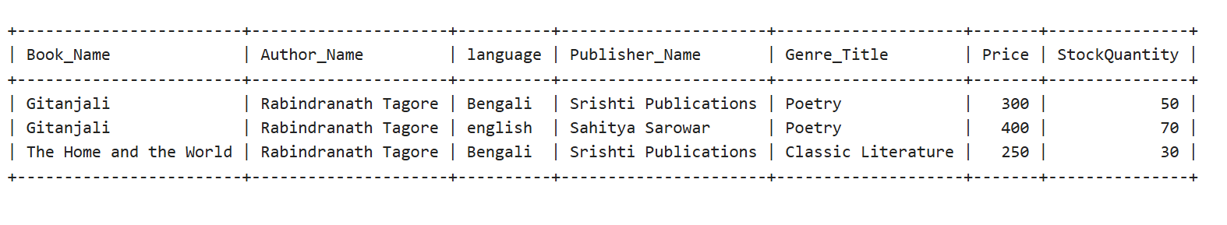

**8.Query to see those books that are published by a specific publisher:**

select Book_Name,Author_Name, language, Publisher_Name, Genre_Title, Price, StockQuantity

from

BOOKS natural join AUTHORS natural join PUBLISHERS natural join GENRE

where Publisher_Name='Bungeishunju Ltd'

order by Book_Name;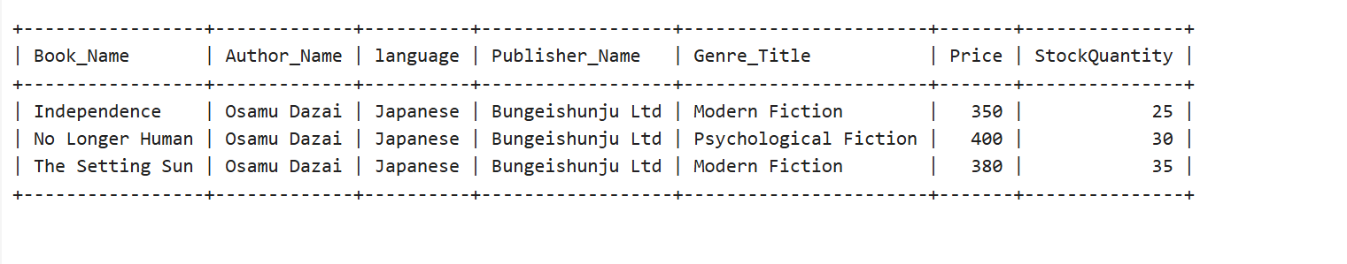

**9.Query to see a specific author's books in any specific languages:**

Select Book_Name, Author_Name, language, Publisher_Name, Genre_Title, Price, StockQuantity

From

BOOKS natural join AUTHORS natural join PUBLISHERS natural join GENRE

where Author_Name='Haruki Murakami' AND (language ='english' OR language ='Japanese');

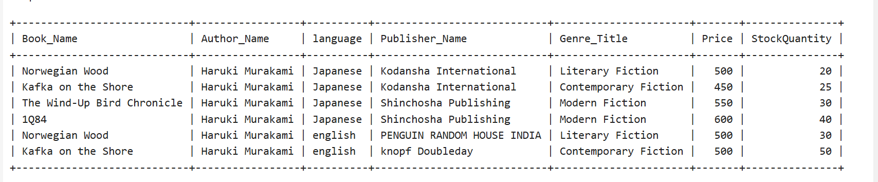

**10.Query to count the total number of employees of each department:**

SELECT

dept_name,count(Employee_ID) as no_of_employee

FROM

EMPLOYEES group by dept_name;

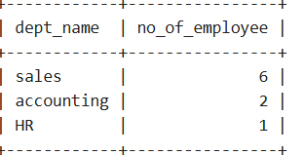

**11.query to see the total number of books stored in the stock and the total number of sold books from stock:**

SELECT sum(Total_Stock) as total_number_of_books_store_in_stock,

sum(Sold_Stock) as total_number_of_sold_books_from_stock

from INVENTORY;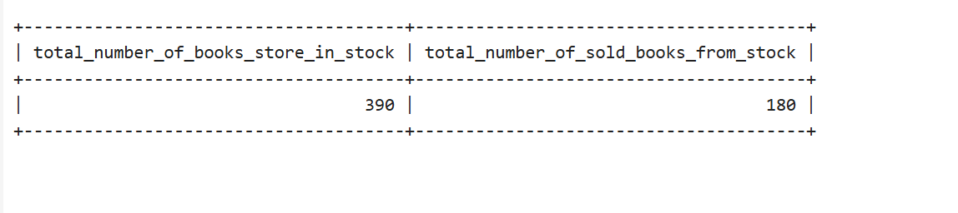

**12. Query to see average salary of employee:**

SELECT avg(salary) as averag_salary from EMPLOYEES;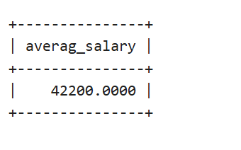

**13. Query to see the highest sold book:**

SELECT

Book_Name as highest_sold_book from books , INVENTORY where

books.BOOK_ID = INVENTORY.BOOK_ID

AND

Sold_Stock >= all (SELECT Sold_Stock from INVENTORY);

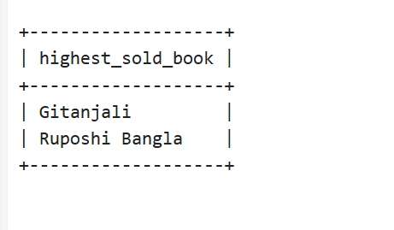

**14. Query to retrieve the amount of books purchased by a customer in a month from the ORDERS table:**

SELECT

CUSTOMERS.Customer_Name,

MONTH(ORDERS.Order_Date) AS Month,

SUM(Total_Quantity) AS Total_Books_Brought

FROM

ORDERS

JOIN

CUSTOMERS ON ORDERS.Customer_ID = CUSTOMERS.Customer_ID

WHERE

YEAR(ORDERS.Order_Date) = 2024

AND MONTH(ORDERS.Order_Date) = 12

GROUP BY

CUSTOMERS.Customer_Name, MONTH(ORDERS.Order_Date);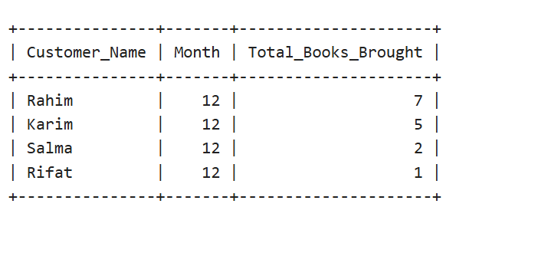

**15. query to see those authors' books whose name's first letter starts with 'O':**

SELECT Book_Name,Author_Name

from

BOOKS,AUTHORS

WHERE

BOOKS.Author_ID = AUTHORS.Author_ID

AND

Author_Name LIKE 'O%';

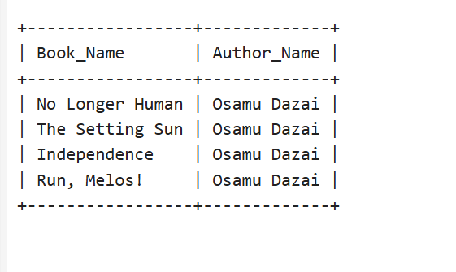

**16. Query to find the book with the minimum price:**

SELECT

Book_Name AS Minimum_Price_Book, Price

FROM

BOOKS

WHERE

Price IN (SELECT MIN(Price) FROM BOOKS);

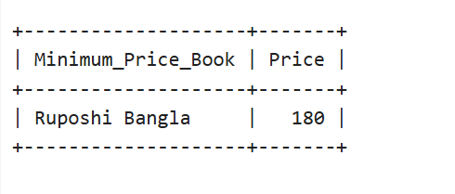

**17. Query to find the book with the maximum price:**

SELECT

Book_Name AS Maximum_Price_Book, Price

FROM

BOOKS

WHERE Price IN (SELECT MAX(Price) FROM BOOKS);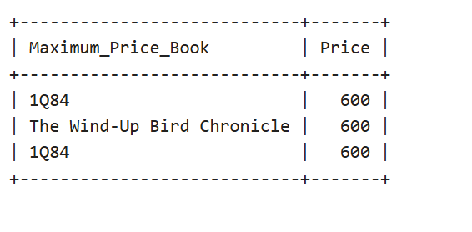

**18. Query to see list all authors whose books are available in multiple languages:**

SELECT

Author_Name

FROM

AUTHORS AS A

JOIN

BOOKS AS B ON A.Author_ID = B.Author_ID

GROUP BY

A.Author_Name

HAVING

COUNT(DISTINCT B.Language) > 1;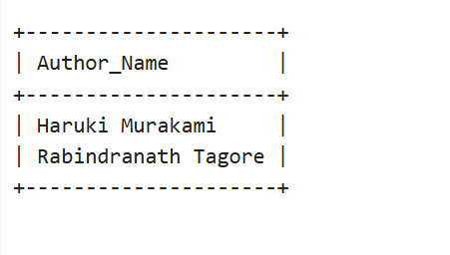

**19. Query to see list the names of employees earning more than 40,000:**

SELECT

Employee_Name, Role, Salary

FROM

EMPLOYEES

WHERE Salary > 40000;

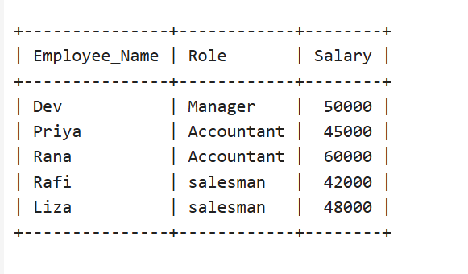

**20. Query to see find the total quantity and value of all books supplied by each supplier:**

SELECT

Supplier_Name, SUM(Quantity) AS Total_Quantity, SUM(Sub_Total_Price) AS Total_Value

FROM

SUPPLY_DETAILES natural join SUPPLIERS

GROUP BY Supplier_ID;

